The Introductory Rites - A Presentation

Task:
In groups of 3 you and your group members are to use the web sites to create a PowerPoint presentation of no more than 6 slides.

The websites are:
http://www.catholicmass.org/english.html
http://vimeo.com/channels/missal
http://www.togetheratonealtar.catholic.edu.au/receive/dsp-content.cfm?loadref=44

In your PowerPoint you must have the following:
- The steps of The Introductory Rites (what comes first, second, third, etc)
- What the Priest does during The Introductory Rites
- What the people do during The Introductory Rites
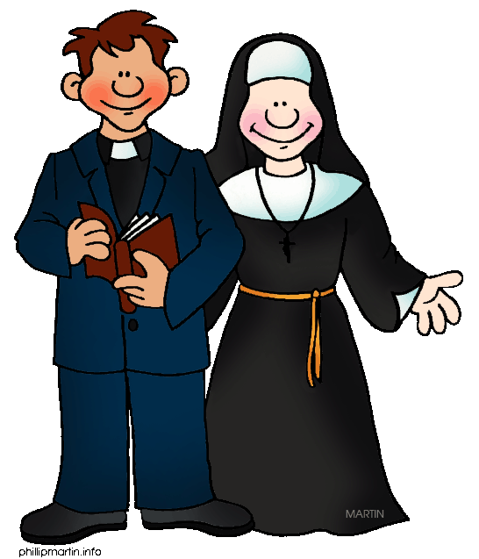
- Images of objects that are important

